

**FINOLEX ACADEMY OF**

**MANAGEMENT AND**

**TECHNOLOGY, RATNAGIRI**

This is to certify that the project report titled: Pet Shop Management System

Carried out by student of MCA Submitted By:

Mr.Nitant Deulkar, Mr.Om Awasare & Mr. Chandan Howale

In partial fulfillment of the award for degree of

MASTER OF COMPUTER APPLICATION

From Mumbai University And is/are the bonafide records of the work done by him/her/them during the Semester I of A.Y 2023- 2024

|  |  |
| --- | --- |
| Internal Guide | HOD |
| Prof. Kishore Bhosale. | Prof. Tejas Joshi. |

# DECLARATION

We Nitant Deulkar, Om Awasare & Chandan Howale student of MCA hereby declare that the Project titled “Pet Shop Management System” which is submitted by us to , Finolex Academy of Management and Technology ,P-60, P60/1, Midc, Mirjole Block, Ratnagiri, in partial fulfillment of requirement for the award of the degree of MCA . has not been previously formed the basis for the award of any degree, diploma or other similar title or recognition. The Author attests that permission has been obtained for the use of any copy righted material appearing in the Dissertation Project report other than brief excerpts requiring only proper acknowledgement in scholarly writing and all such use is acknowledged.

**Place- RATNAGIRI Student Name-**

Nitant Deulkar.

Om Awasare.

Chandan Howale.

**Date-**

## ABSTRACT

The "Pet Shop Management System" project is a dynamic Java standalone application aimed at revolutionizing pet shop operations. This project involves the creation of an intuitive and user-friendly software solution for managing inventory, sales, and customer interactions in pet shops. Through meticulous planning and innovative development methodologies, the project focuses on bridging the gap between pet shop owners and customers seeking high-quality pets and pet products.

The standalone application integrates advanced functionalities for enhanced user experience, including seamless transaction processing, inventory management, and a user-friendly interface for customers. This abstract encapsulates the essence of a comprehensive project that addresses the specific needs of the pet industry, setting a benchmark for user-centric digital solutions. The project's success is a testament to technical expertise, strategic planning, and dedication to delivering excellence in pet shop management.

**ACKNOWLEDGEMENT**

It gives us immense pleasure to present the report of our project here. It has been quite an experience, facing several problems at stages and coming up with appropriate solutions, at times the discussion amongst us or suggestions from our friends and teachers.

We thank our guide Prof. Kishor Bhosale, Department of Master of Computer Application, in the best possible way. Without her guidance, it wouldn’t have been possible to reach this stage. We are very grateful for his support and motivation.

We express our gratitude to Prof. Tejas V. Joshi, Professor and Head of the Department, Master of Computer Application for his invaluable suggestions and constant encouragement.

Lastly, we would like to put our thanks on record to the teaching and non-teaching staff for rendering their support directly or indirectly.

## BUSINESS CASE

1. Executive Summary:

The Pet Shop Management System is a Java standalone application aimed at streamlining pet shop operations. This project involves the development of a user-friendly software solution to manage inventory, sales, and customer interactions efficiently. The system addresses the challenges of manual record-keeping in pet shops, offering a digital platform for seamless exploration, selection, and purchase of pets and related products. This initiative supports the enhancement of pet shop management and customer experience in the ever-evolving pet industry.

1. Introduction:

The Pet Shop Management System project presents a compelling business case for the development of a Java standalone application. The intention is to create a digital platform that simplifies pet-related transactions. This system aims to offer a diverse range of pet products, serving as a centralized hub for pet enthusiasts and owners. By streamlining pet shop operations through digitalization, the project aligns with the goal of providing a comprehensive and user-friendly solution for managing inventory, sales, and customer interactions in the pet industry.

1. Statement of the Problem:

Pet shops face a challenge due to the lack of a dedicated online platform, limiting customer access to diverse pet products. The manual processes hinder efficient management and hinder the pet industry's adaptation to digital trends. The Pet Shop Management System, a standalone Java application, aims to address this problem by providing a user-friendly solution for managing inventory and enhancing the overall customer experience.

1. Analysis:

To tackle the identified problem, a comprehensive analysis has been conducted for the Pet Shop Management System. This analysis considers market trends, customer preferences, and strategic objectives. Market research reveals an increasing demand for dedicated online platforms in the pet industry. The absence of such a system can potentially impact the pet shop's revenue and market position. The standalone Java application aims to address this gap by aligning with market trends, fulfilling customer preferences, and supporting the organization's strategic goals in the pet industry.

1. Discussion of Possible Options:

Benefits:

Market Expansion: The Pet Shop Management System's development as a Java standalone application offers the opportunity to tap into the expanding e-commerce market for pet-related products, reaching a wider audience and increasing market presence.

Brand Visibility: The standalone application acts as an additional touchpoint for pet shop customers, enhancing brand visibility. It has the potential to attract new customers who appreciate the convenience of managing pet-related transactions online, thereby strengthening the brand's overall presence in the pet industry.

Costs:

Development Costs: Initial investment for Java standalone application development, covering platform design and e-commerce functionality.

Maintenance Expenses: Ongoing costs for regular updates and technical support to ensure optimal performance of the Pet Shop Management System.

Time-scale:

Development Time: Six-month timeline for Pet Shop Management System development, ensuring a seamless user experience with thorough testing.

Return on Investment: Anticipate ROI within the first year as the standalone Java application gains traction and boosts customer engagement in the pet industry.

Risks:

Competition: Risk of market share competition in the online pet industry.

Technical Challenges: Potential technical glitches or delays during Java standalone system development may impact the project timeline.

6. Recommendation:

Proceed with developing the Pet Shop Management System as a Java standalone application (Option 1). Despite initial costs and potential risks, the long-term benefits in revenue generation and market positioning outweigh the drawbacks. This aligns with the goal of enhancing pet inventory management and customer experience in the pet industry.

## TABLE OF CONTENT

|  |  |  |
| --- | --- | --- |
| Sr no | Content | Page No |
| **1.** | **Introduction** | 10 |
|  | 1.1 Background | 10 |
|  | 1.2 Objectives | 10 |
|  | 1.3 Purpose, Scope and Applicability | 11 |
| **2.** | **Survey Of Technologies** | 12 |
|  | 2.1 Existing Systems and its Limitations | 12 |
|  | 2.2 Proposed System | 13 |
| **3.** | **Requirements and Analysis** | 14 |
|  | 3.1 Requirement Specifications | 14 |
|  | 3.2 Planning And Scheduling – Gantt Chart | 15 |
|  | 3.3 Hardware Requirements | 15 |

|  |  |  |
| --- | --- | --- |
|  | 3.4 Software Requirements | 15 |
|  | 3.5 Preliminary product Description | 15 |
|  | 3.6 ER And UML Diagrams | 16 |
| **4.** | System Design | 19 |
|  | 4.1 Modules | 19 |
|  | 4.2 Data Design | 20 |
|  | 4.3 User Interface Design | 22 |
|  | 4.4 Test Case Design | 25 |
| **5.** | Conclusion | 26 |
| **6.** | Bibliography | 27 |

**TABLE OF FIGURES**

|  |  |  |  |
| --- | --- | --- | --- |
| **Sr. No.** |  | **Figures** | **Page No.** |
| 1. | Fig 1: Planned Gantt Chart |  | 15 |
| 2. | Fig 2: ER Diagram |  | 16 |
| 3. | Fig 3: Use Case Diagram |  | 16 |
| 4. | Fig 4: Class Diagram |  | 17 |
| 5. | Fig 5: Sequence Diagram |  | 17 |
| 6. | Fig 6: Deployment Diagram |  | 18 |
| 7. | Fig 7: Activity Diagram |  | 18 |
| 8. | Fig 8: Home Page |  | 22 |
| 9. | Fig 9: Product Page |  | 22 |
| 10. | Fig 10: About Us Page |  | 23 |
| 11. | Fig 11: Contact Us Page |  | 23 |
| 12. | Fig 12: Cart Page |  | 24 |

## 1. INTRODUCTION

* 1. **Background**

The "Pet Shop Management System" is a straightforward Java standalone application tailored for the efficient management of offline pet shops. This project serves as a practical system for overseeing various aspects of a pet shop, offering a user-friendly solution for both individuals and businesses involved in pet retail.

The system streamlines the process of managing and ordering pet inventory, ensuring that products are readily available. With features designed for simplicity, this system becomes a valuable tool for enhancing the operational efficiency of pet shops. It provides a user-friendly online platform that simplifies the tasks of finding, purchasing, and managing high-quality pets and pet products. The implementation of this system aims to bring about improvements in the organization's quality and transparency, offering a streamlined approach to offline pet shop management.

**1.2 Objective**

The objective of the Pet Shop Management System, a Java standalone application for managing offline pet shops, is to provide a convenient and efficient platform for customers to access and obtain a wide range of pets and pet-related products.

The system aims to simplify the process of finding and purchasing specific pets and products, catering to various breeds and categories. It strives to offer a diverse inventory, ensuring customers can easily locate the right pets and accessories without the need to visit physical stores.

The system's primary focus is to streamline the ordering process, allowing customers to search for pets and products, add them to their cart, and complete the transaction with minimal effort. Competitive pricing, promotions, and discounts are integrated to ensure customers receive good value for their purchases. Additionally, the system provides multiple channels for customer assistance, including phone support, email, and live chat, enhancing the overall customer experience in managing offline pet shops.

**1.3 Purpose, Scope, Applicability**

1.3.1 Purpose

The purpose of the "Pet Shop Management System," a Java standalone application, is to provide a streamlined platform for managing offline pet shops. It simplifies the process of exploring, selecting, and purchasing pets and pet-related products, offering a user-friendly experience for both pet shop owners and customers. The system aims to enhance overall pet shop management, ensuring efficiency and convenience in offline operations.

1.3.2 Scope:

The system will provide an online platform where users, including vehicle repair shops and individual vehicle owners, can search for, select, and order vehicle parts.

The system will maintain a comprehensive database of vehicle parts, including compatibility information for various vehicle makes, models, and years.

The system will facilitate effective communication with customers throughout the order and delivery process.

This project is about Automobile accessories management application and will consist of some modules

1. Product Module
2. Shopping cart Module
3. Order Module
4. Customer Module
5. Admin Module
6. Supplier Module
7. Inventory Module

1.3.3 Applicability

The Website is applicable to a wide range of users, including:

* Customers: Individuals looking to purchase high-quality automobile accessories with the convenience of online shopping and doorstep delivery.
* Automobile Accessory Retailers: Businesses specializing in the sale of automobile accessories seeking an online presence and an efficient delivery system.
* Logistics and Delivery Services: Companies providing delivery services for automotive products.
* Manufacturers: Suppliers and manufacturers of automobile accessories aiming to reach a broader customer base through an online platform.

## 1) Introduction:-

The "Pet Shop Management System" is a dedicated solution crafted to address the challenges of manual pet shop management. Tailored for the specific needs of the pet shop, the software ensures a seamless and effective operational environment. With a user-friendly interface, it minimizes data entry errors and accommodates users of varying skill levels.

This comprehensive system encompasses various modules, including pet, category, user, customer, billing, and logout sections. Each module contributes to the efficient management of pet-related data, providing an organized and centralized approach.

The pet shop industry encounters difficulties in handling information related to pets, inventory, customers, and billing. The Pet Shop Management System strives to streamline these processes, offering a user-friendly and organized platform for enhanced efficiency and improved management of pet shop activities.

## 2. Project Objectives:-

The primary objective of the Book Store Management project is to modernize and optimize the operations of bookstores through the implementation of advanced technology and efficient management practices. Our goal is to create a user-friendly platform that simplifies inventory control, sales monitoring, and customer interactions, ultimately enhancing the overall bookstore experience.

1. Streamline Inventory Management: Develop a robust system to efficiently track and manage book inventory, reducing errors and improving stock accuracy.

1. Enhance Sales Tracking: Implement a comprehensive sales tracking mechanism to monitor book sales trends, analyze customer preferences, and identify opportunities for growth.

1. Improve Customer Engagement: Integrate features that enhance customer experience, such as personalized recommendations, loyalty programs, and efficient order processing.

1. Real-time Analytics: Provide real-time data analytics to empower bookstore owners with insights into sales performance, popular genres, and inventory turnover rates.

1. Barcode Scanning: Incorporate barcode scanning technology for swift and accurate book identification, speeding up the checkout process and minimizing errors.

1. Integrated Payment Gateways: Facilitate seamless and secure transactions through integrated payment gateways, ensuring a smooth and convenient purchasing experience for customers.

1. Accessibility and Scalability: Design the system to be accessible from various devices and scalable to accommodate the growth of the bookstore business.

## 3. Technologies Used:-

Front End : HTML, CSS, BOOTSTRAP

Back End : PHP, MySQL

Tools & Technologies : Xamp Server,

MySQL Queries,

Browser (Mozila Firefox, Chrome..)

Text Editor(Sublime Text 3, Notepad ++..)

## 4. System Architecture:-

* The front-end of the application is built using React and Tailwind CSS.

* The back-end is developed using Node.js.

* MongoDB is used to store product information, user profiles, and order data.

**Modules :-**

Admin Module:- i] Add / delete book ii] Add / delete publisher iii] Add /delete Category

User Module :- i] Create Account. ii] Search book. iii] View book.

Iv] Add the book into cart.

V] Buy the book.

## 1. Key Features:-

1. **User Authentication:-** Users can create accounts, log in, and update their profiles.

1. **Product filtering:-** A comprehensive listing of products with filtering and searching capabilities.
2. **Product Details:-** Detailed product pages with images, descriptions, and specifications.

1. **Shopping Cart:-** Users can add products to their cart, update quantities, and remove items.
2. **Checkout Process:-** Secure checkout process with payment integration using Stripe.

1. **Responsive Design:-** The website is designed to be accessible on various devices, including desktops, tablets, and smartphones.

## 2. Development Process:-

1. Requirement analysis and design planning.

1. Designing and implementing the user interface components.

1. Testing the Website for functionality, responsiveness.

## 3. Challenges Faced:-

* Managing user authentication and authorization.

* Designing a responsive user interface that works well on different screen sizes.

## 4. UML Diagrams :- 1) ER Diagram :-



BMS

Contai

ns



Cart



Books



imag



name



id



qty



price



name



price



imag



Cat..



desc



id



Category



Has

Ma



name



id



Customers



Buy

s



id



name



passwor



city



e

-



con

-



date

## 2) Use case Diagram:-



BOOKSTORE MANAGEMENT SYSTEM



View Books



Order



Login



Add to Cart



Register



Add Cat, Books



Delete Cat, Books



Delete User



User



Visitor



Admin

**3) Activity Diagrams :**



Home Page



View Books



Select Book



Add to Cart



Book Detail



Register



Login



Added to Cart



Submit Order



Order Placed



No



**ii] DATA FLOW DIAGRAM:-**

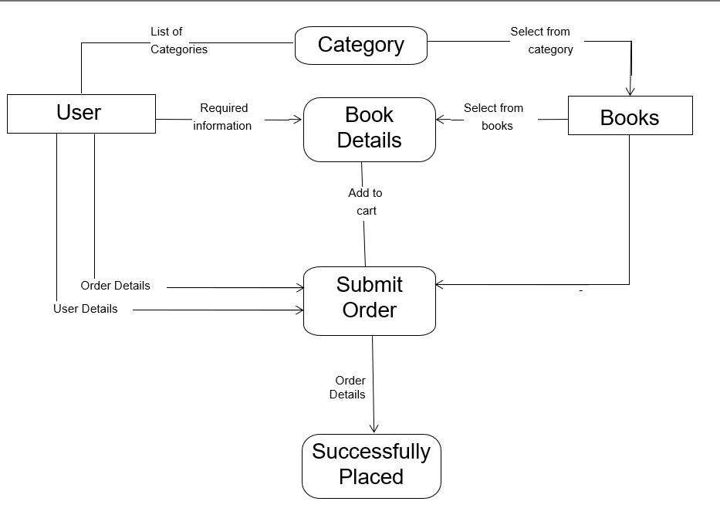

## ii] Component Diagram:-

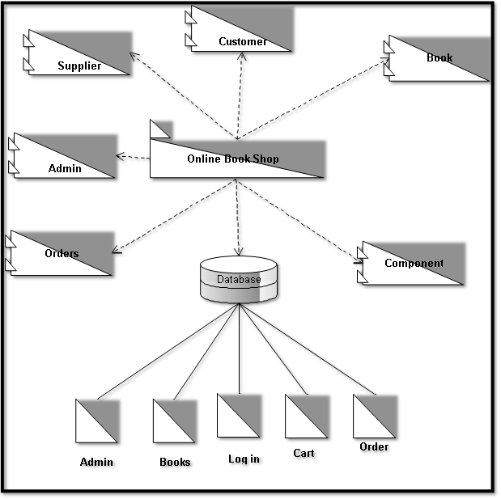

123

**5. System Outputs :-**

## Home Page :-



## Register Form :-

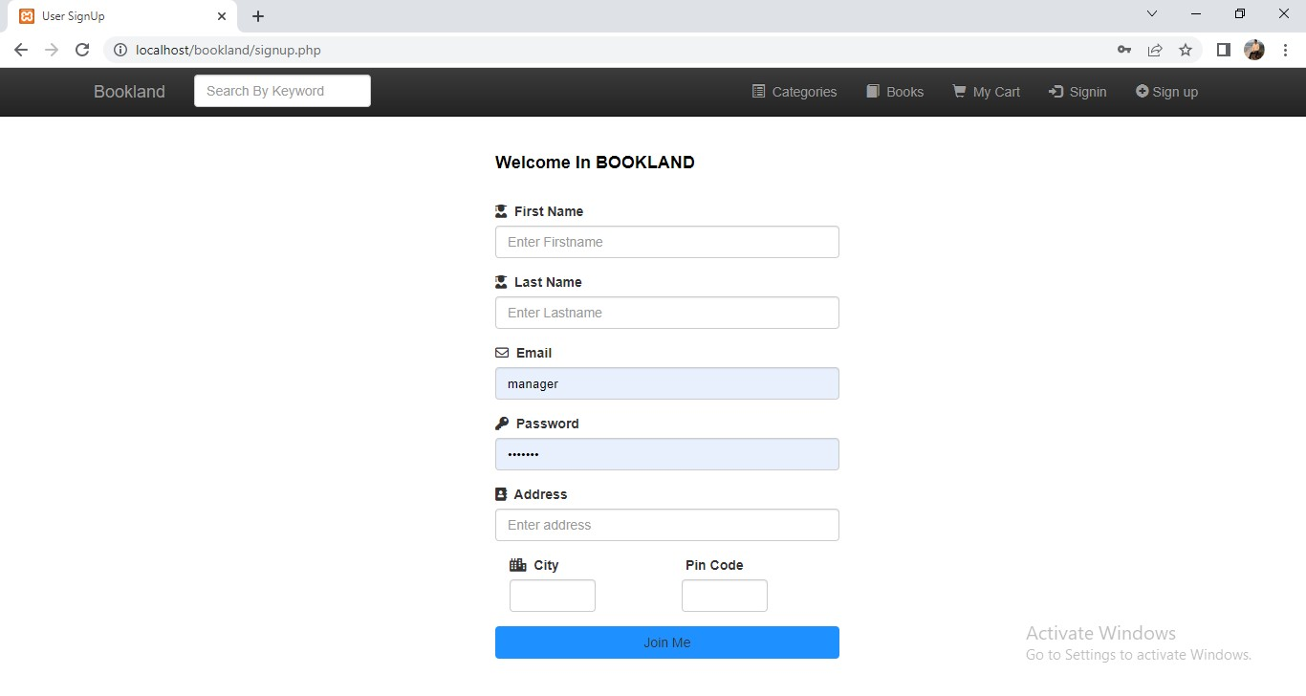

## Login Form :-

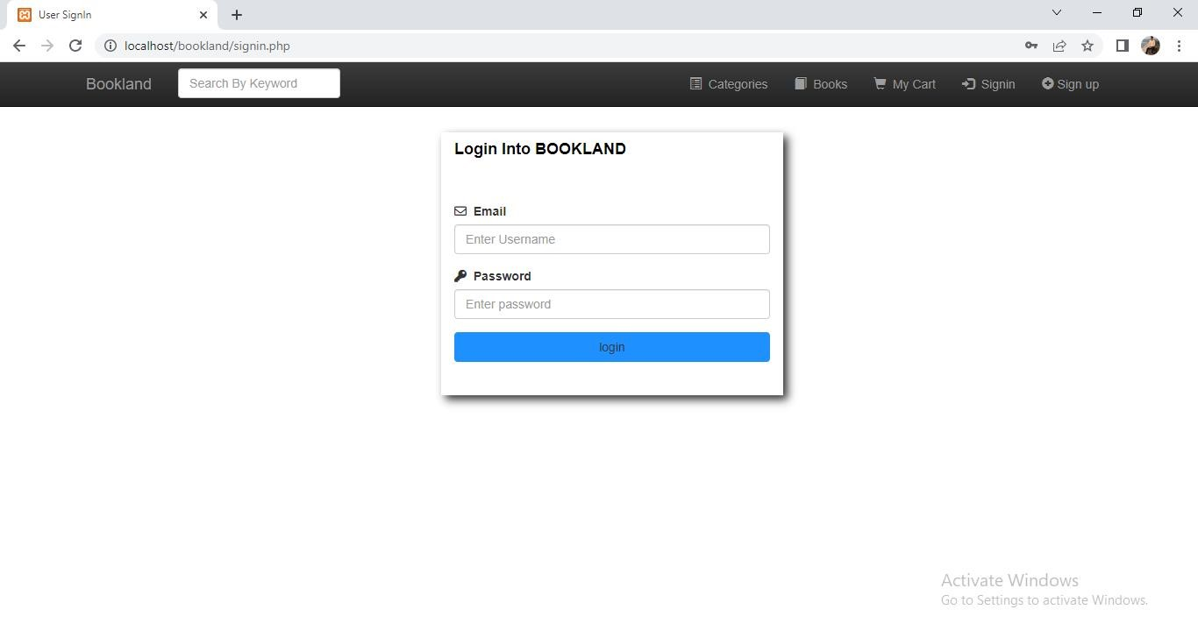

## All Books :-

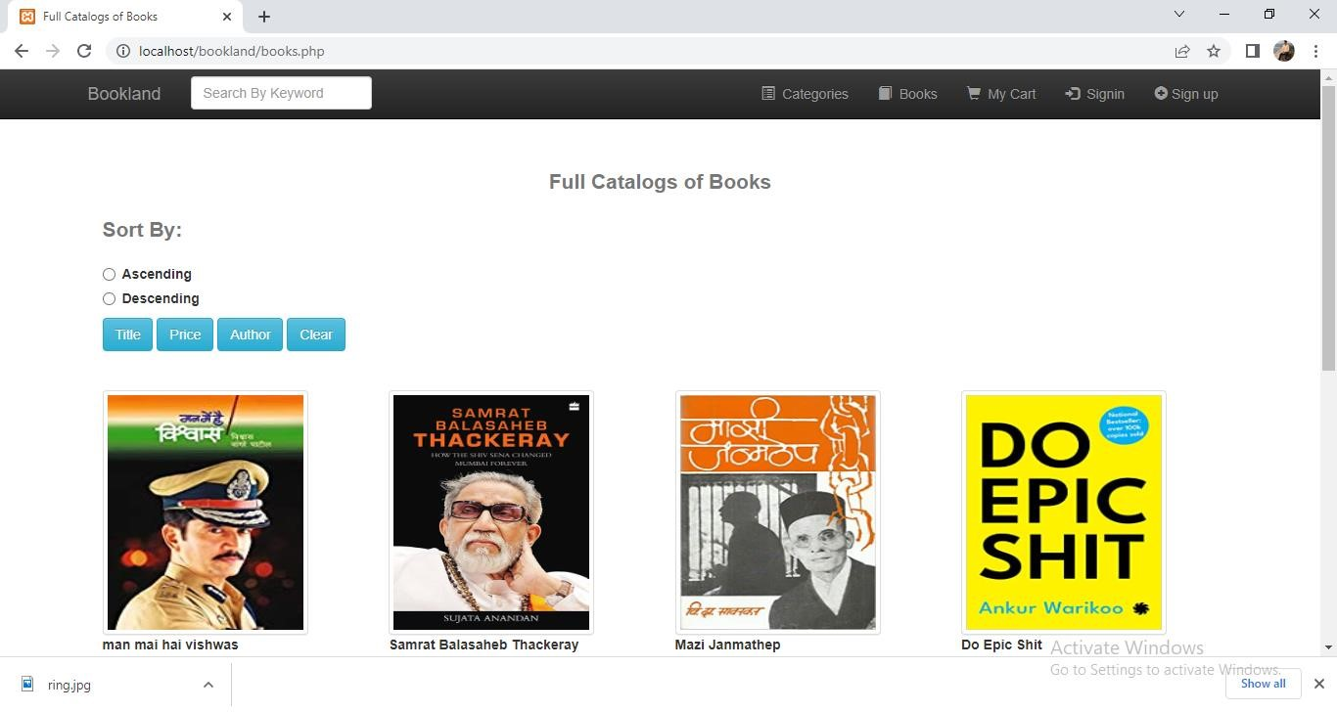

## Search Books :-

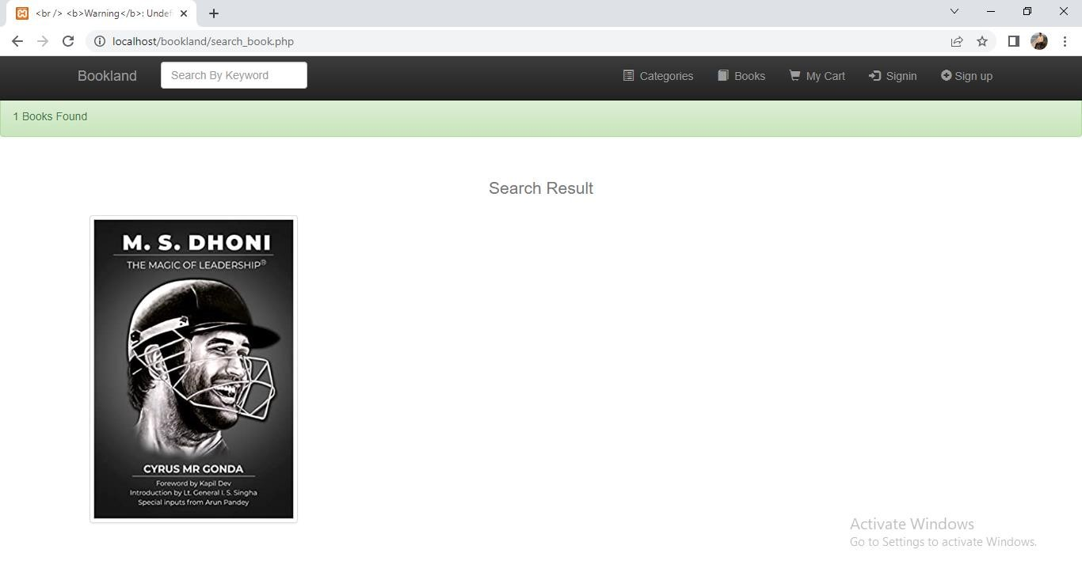

## Book Details :-

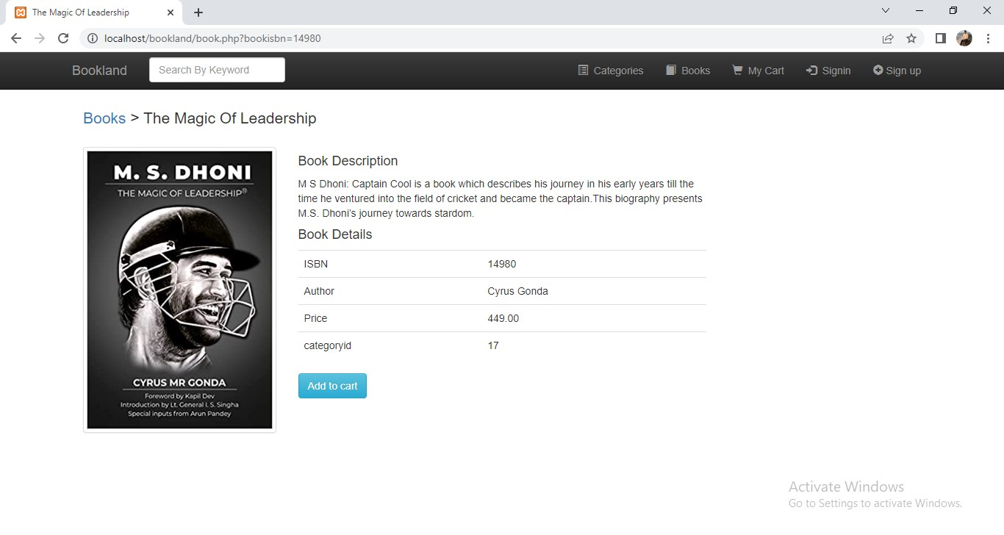

## CART:-

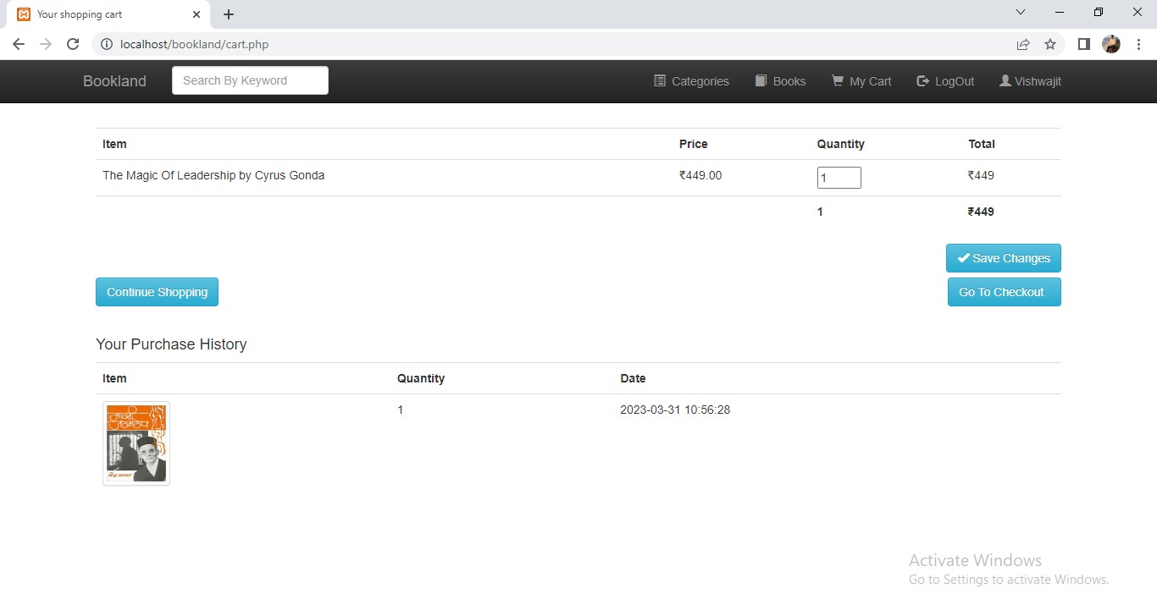

## Confirmed Purchased :-

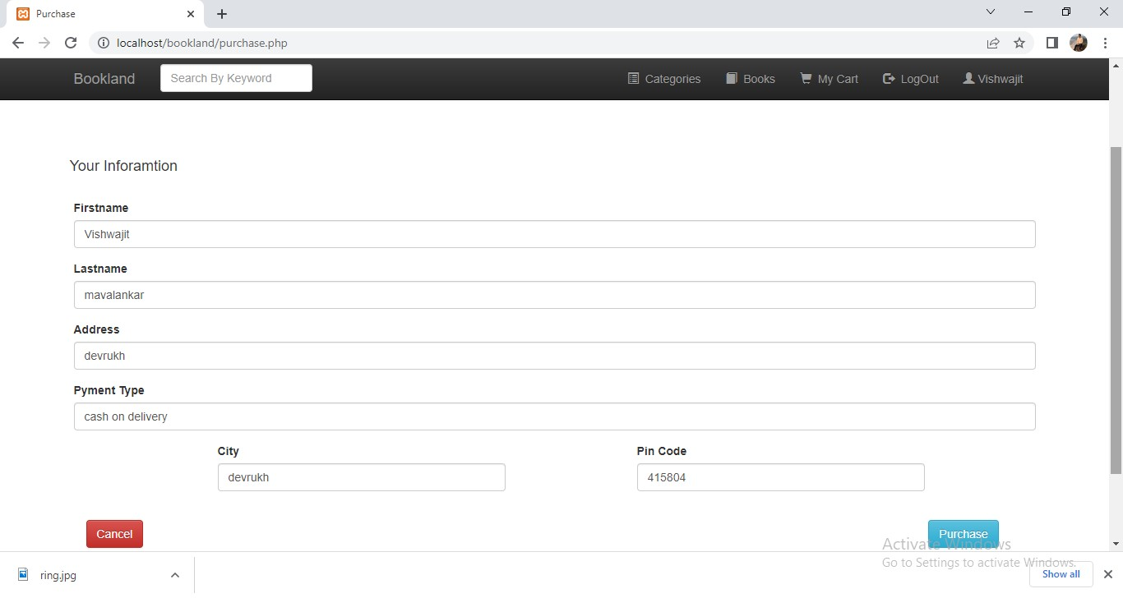

## Order Page :-

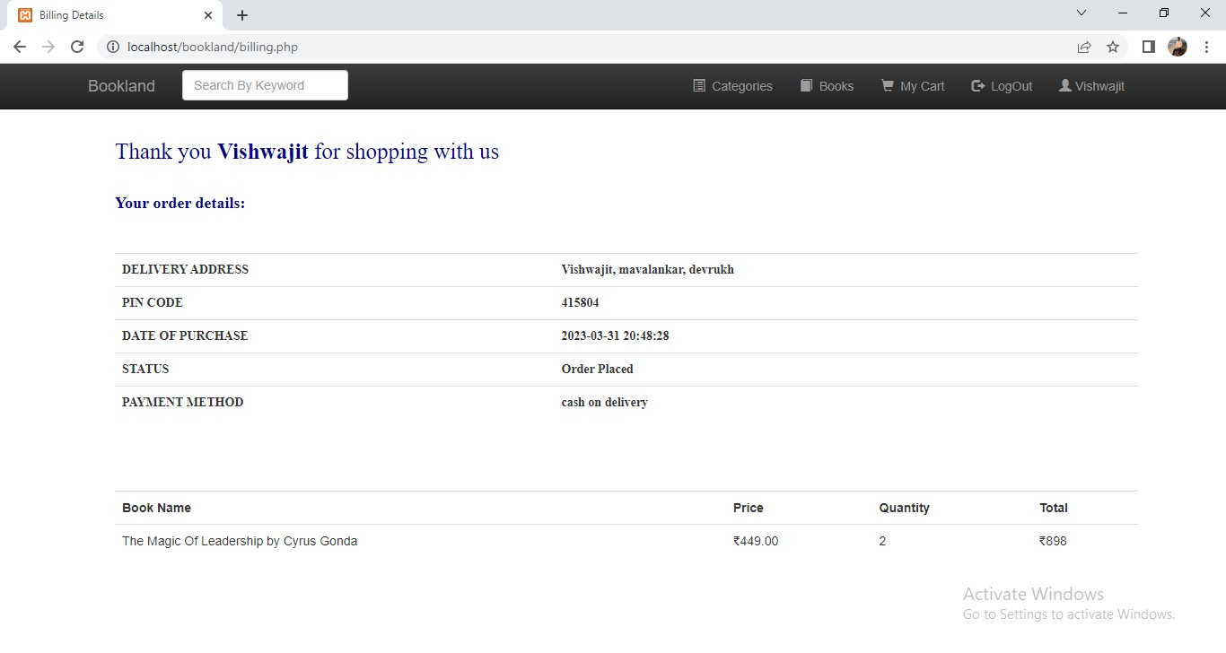

## Admin Login Page :-



## Admin Add Publisher:-

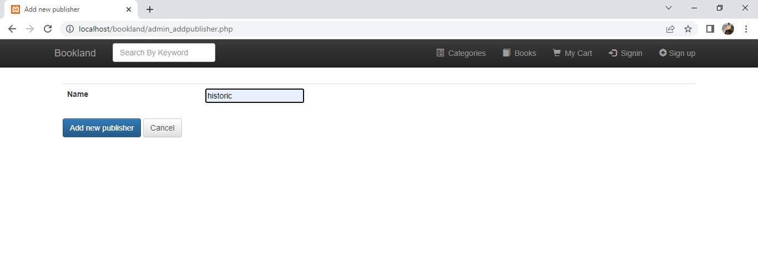

## All Publisher :-

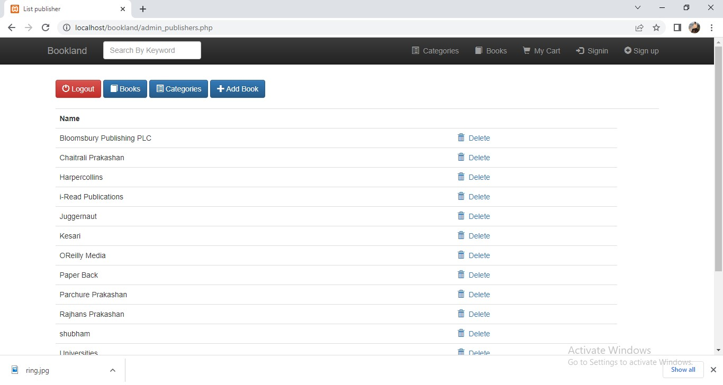

## Admin adds book:-

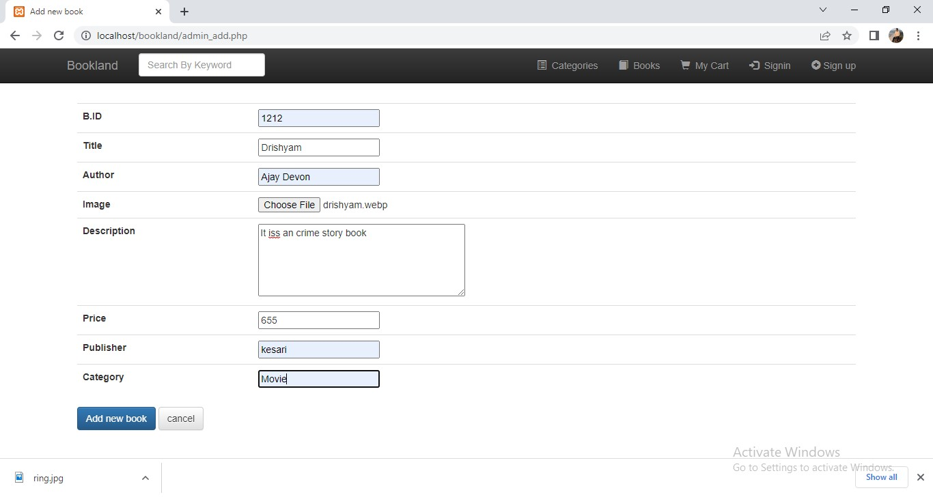

## Add Category:-

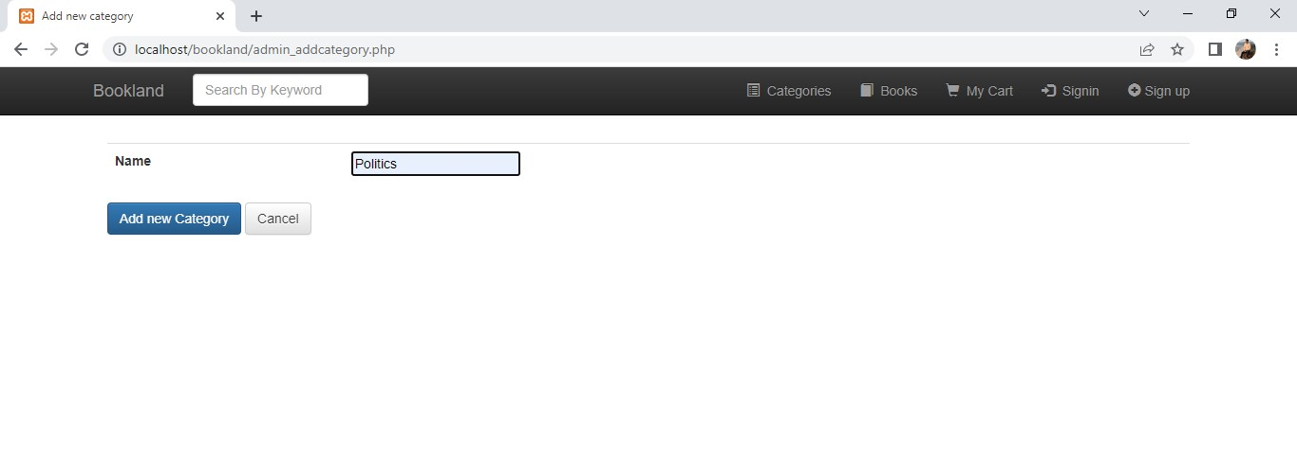

## All Categories:-

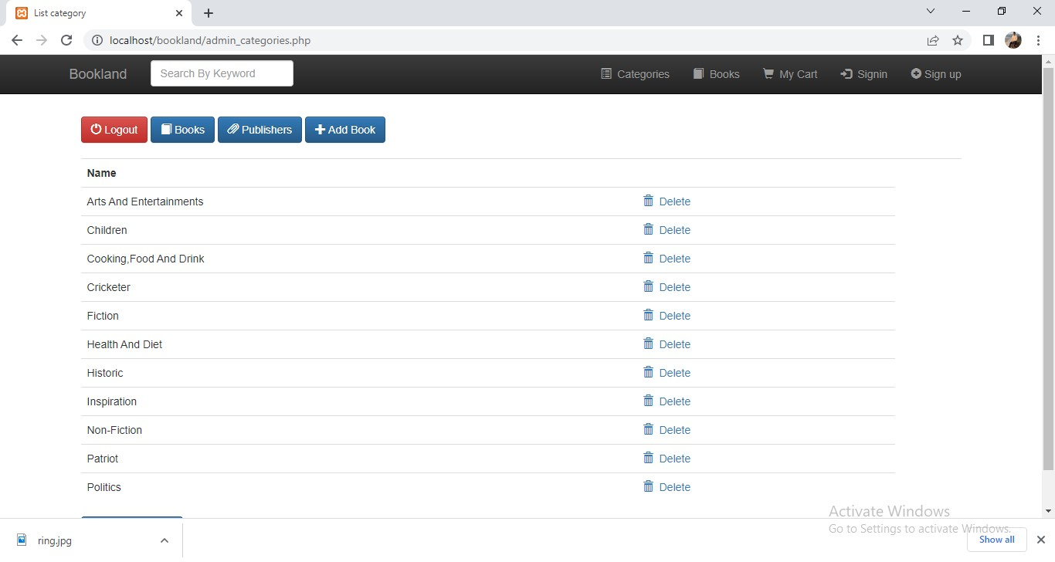

## Admin log in table :-

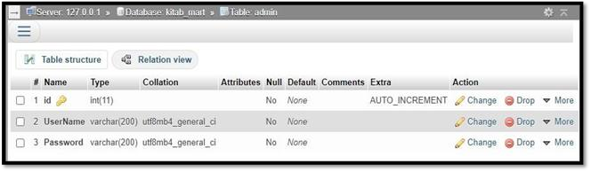

## Books table :-

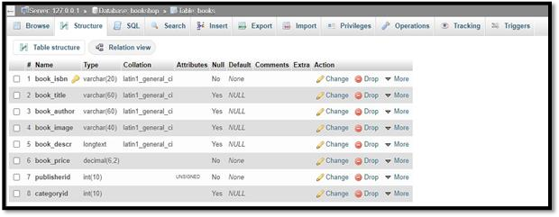

**Cart table :**

**-**

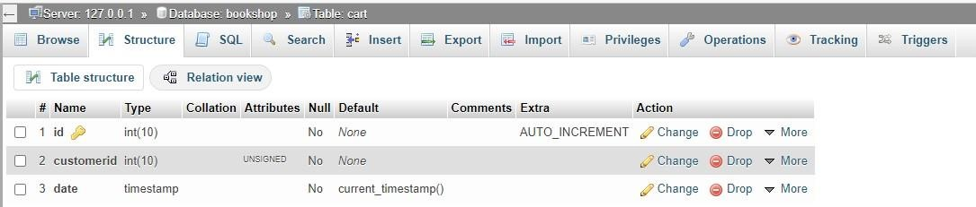

## Customer table :-

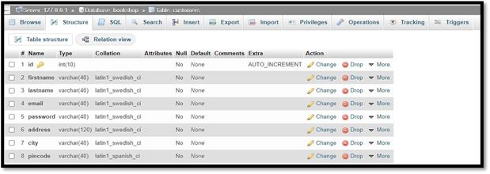

## Publisher table :-

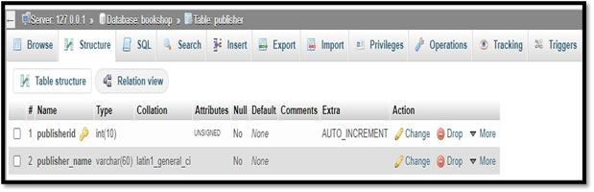

## Manager table :-

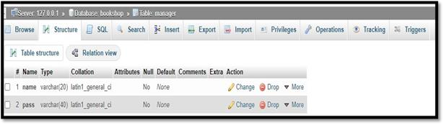

## 6. Future Enhancements:-

1. AI-Optimized Inventory Forecasting.
2. Blockchain-secured Financial Transactions.
3. Virtual Reality Bookstore Tours.

## 7. Conclusion:-

In summary, the Book Store Management project optimizes bookstore operations for efficiency and accuracy. With a customer-centric approach, it enhances relationships through personalized features. The real-time analytics and sales tracking offer valuable insights for strategic growth. Leveraging modern technology, the project ensures bookstores are future-ready and adaptable. Ultimately, it stands as a transformative solution for ushering traditional book retailing into a more streamlined and tech-savvy era.

➢ **10. References:**

[https://www.google.com](https://www.google.com/) [https://www.youtube.com](https://www.youtube.com/) https://www.w3schools.co [https://stackoverflow.com](https://stackoverflow.com/) [https://www.quora.com](https://www.quora.com/)

[https://www.scribd.com](https://www.scribd.com/) [https://www.udemy.com](https://www.udemy.com/)